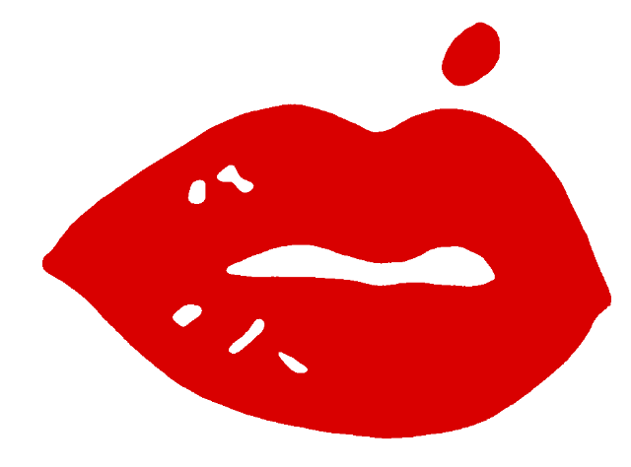 Wine Maker Tribute Release
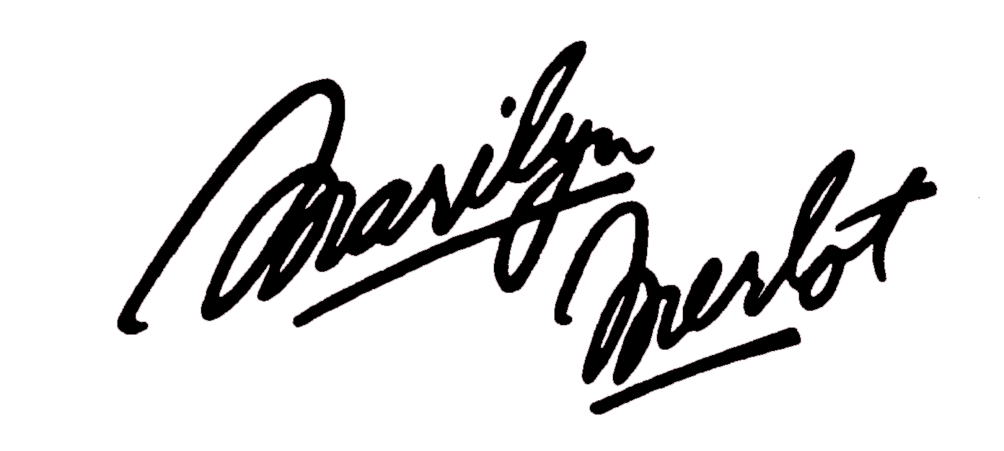

2012 Marilyn Merlot - Napa Valley – Retiring Winemaker John McKay

It started as a whimsical suggestion offered at a dinner party in Napa Valley. Two years later, the 1985 vintage of Marilyn Merlot made its entrance in the wine world and the rest, as they say, is history. Marilyn Merlot has achieved a stardom of its own over the years, attracting not only fans of Marilyn Monroe, but lovers of fine Napa Valley Merlot, offering what wine author Leslie Sbrocco calls “glamour in a glass.”
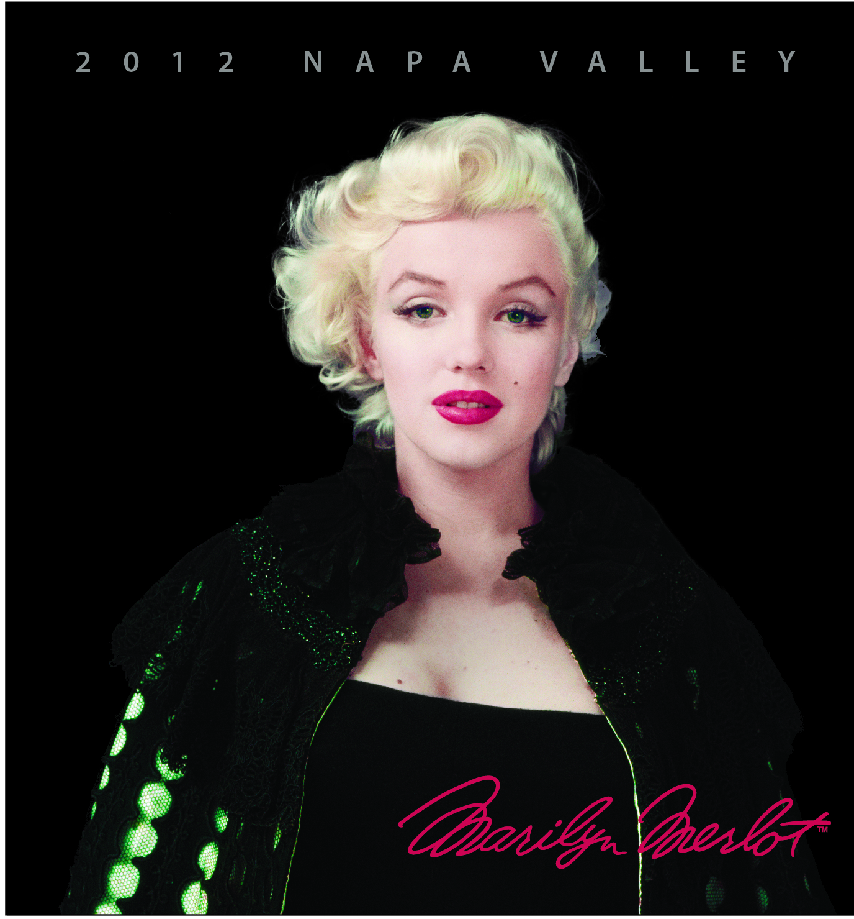
Marilyn Monroe began with a bit part as a telephone operator in The Shocking Miss Pilgrim, in 1947, and ended with her compelling role in The Misfits in 1961. Her movie career spanned just 14 years. Now in its 28th vintage, Marilyn Merlot is living proof of the iconic power of the image of Marilyn Monroe.
The 2012 Vintage photo was taken in 1955 when Marilyn was living with the Green family in NYC. The “Black Cape” photo-shoot portrayed her freedom from 20th Century Fox’s “Slave Contract”

The 2012 vintage of Marilyn Merlot is the 28th edition, and comes to market September in a very special offering recognizing the 17 years of John McKay’s winemaking at Marilyn Wines. John has made wine from Hanzell to Monticello. He pioneered such practices as sur lie aging of white wines and extended maceration during fermentation of red wines. He has made Marilyn into a wine for

This very special wine is appealing in many ways:

Wine collectors and lovers of Marilyn Merlot have long waited a crowning wine for their collections, and the Silver Anniversary Marilyn Merlot will surely be the “must have” wine of the year.

The 2009 vintage Marilyn Merlot captures the essence of its Napa Valley heritage and is among the finest expressions of Merlot from an outstanding vintage. It will age beautifully for at least a decade.

This is a wine to collect, to enjoy, and to gift. It commands attention when it enters the room, offers seductive aromas and elegant flavors, and has an enduring appeal.
Winemaker’s Note: The 2012 vintage is Ruby-red. Aromas of black raspberry, coffee, smoke with nutty chocolate. Nice complexity and balance, with very good overtones to the currant, herb, cherry and floral flavors. This wine has a restrained sweetness nicely balanced by judicious acidity. Finishes with smooth, light tannins and excellent length. Built to age, but already very easy to drink." Enjoy!Vineyard locations for this are from longtime growers in the Yountville and Oakville regions of the Napa Valley. Wine Maker: John McKay UPC-750ml 8 52600 00400 7
Vineyards: Yountmill Vineyard Harvest Date: September-October 2009 Beckstoffer Vineyard Alcohol 13.9%, Total Acid 0.60g/100ml

Wholesale Price: $240

Special Offering: $225 per case for Pre-sale period!!!!!!! ++++++++++

Order in August-September for October store Delivery:

Account Name: ____________________________________________________ LIMITED AVAILABILITY FOR THESE ITEMS

Account Number: ___________________________________________________

Salesperson: ______________________________________________________

Cases Ordered: 12 Marilyn__________ 13 Sauv Blonde__________ 13 Norma Jean_______ 10 Meritage (six pack) ________

Orders for new release offerings are Due Back By:

Marilyn Monroe is a trademark of Marilyn Monroe-Authentic Brands Group LLC and is being used with permission
Marilyn Merlot Products are Sold and Marketed by www.internationalvines.net 925.283.9460

